**Question-1 Declare a vector with Initialization and print the elements..**

**Ans.**

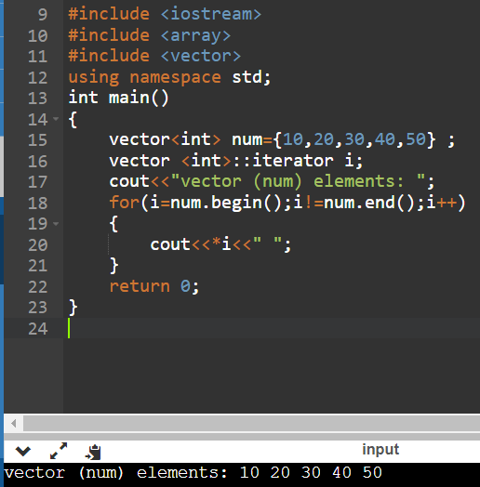

**Question – 2 Declare a vector without initialization, insert some elements and print.**

**Ans.**

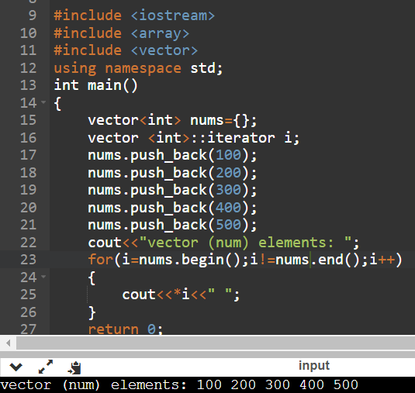

**Question – 3 Write a function to print the element of a vector and take input from the user.**

**Ans.**

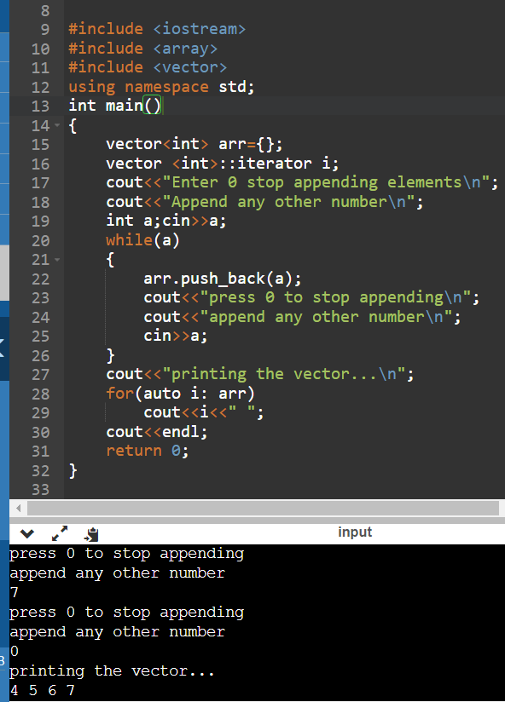

**Question – 4 Write a program to Copy one vector’s elements to another vector.**

**Ans.**

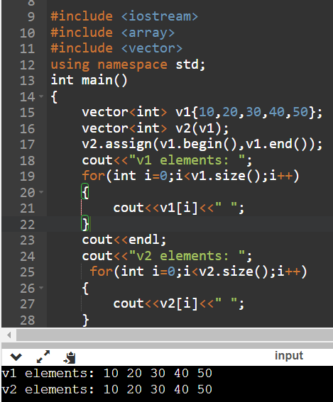

**Question – 5 Find largest and smallest elements in a vector.**

**Ans.**

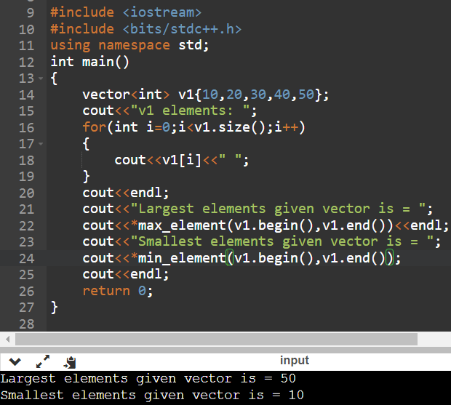

**Question – 6 Write a program to reverse vector elements**

**Ans.**

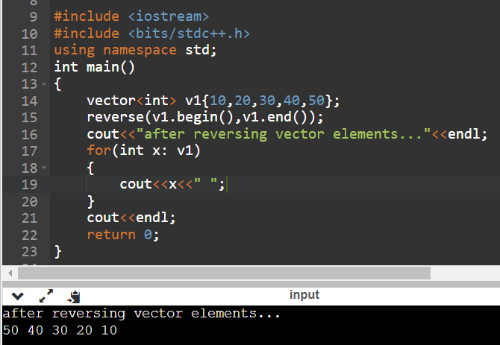

**Question – 7 Write a program to find sum of vector elements.**

**Ans.**

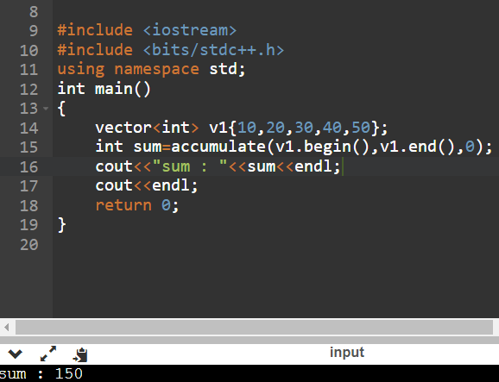

**Question – 8 Write a program to find common elements between two vectors.**

**Ans.**

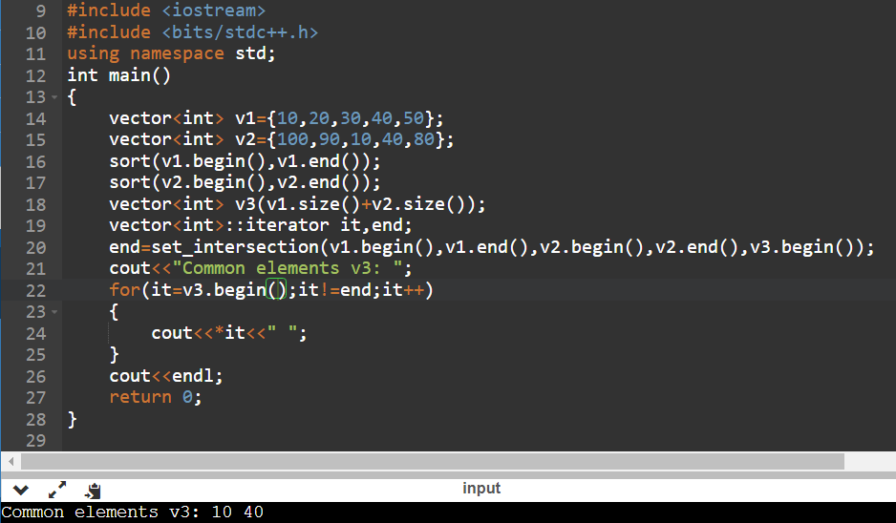

**Question – 9 Write a program to Push and print elements in a float vector.**

**Ans.**

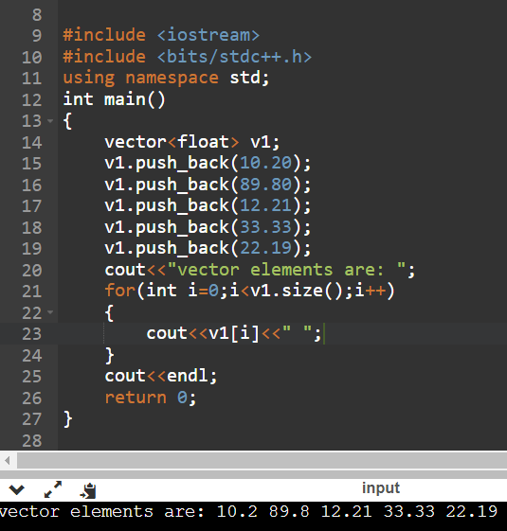

**Question – 10 Write a program to check whether an element exists in a vector or not .**

**Ans.**

